Violent Femmes – American Music
Orginal key: C Us: Same

[Verse] C | F G [4x]

[Chorus]
am | E | F | G | G
C | F | C | G
^^^^^^^ 2nd chorus: played 2x
3rd chorus: repeated til end w/accelerando

Plan
1 Slow Verse (solo voice & guitar)
2 Verses with Band
Chorus 1
Verse
Chorus 2 (see change)
Guitar solo (over 1 verse)
2 Verses a capella
Chorus 3 (see change)

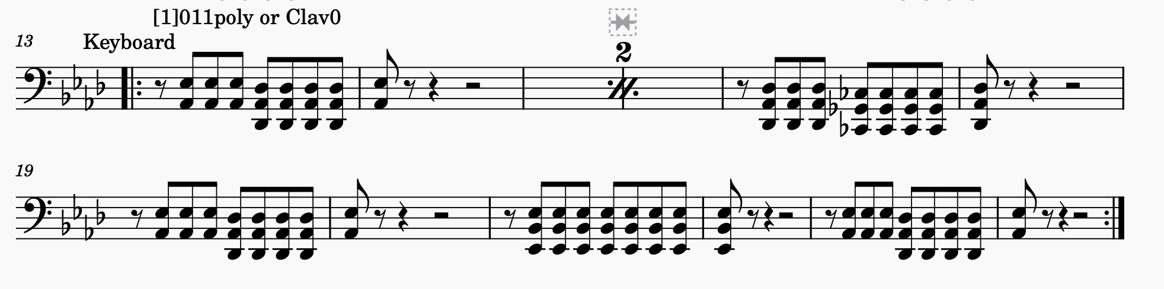
Verse 3  This indecision's bugging me (Esta indecisión me molesta)  If you don't want me, set me free (Si no me quieres, librarme)  Exactly whom I'm supposed to be (Dígame que tengo ser)  Don't you know which clothes even fit me? (Sabes que ropa me "quedrá"?)  Come on and let me know (Me tienes que decir)  Should I cool it, or should I blow? (Me debo ir o quedarme?) | Verse 6 & 7  Should I stay, or should I go now? (Yo me enfrío o lo soplo)  If I go, there will be trouble (Si me voy va a haber peligro)  And if I stay, it will be double (Si me quedo sera el doble)  So ya gotta let me know (Me tienes que decir)  Should I cool it, or should I blow? (Tengo frío por los ojos)

